
School of Computing and
Mathematical Sciences

BSc Final Year Project Form

- Proposal
The student should complete parts 1(a), 1(b), 1(c) and 1(d) below. An electronic version of this form should be uploaded to the Final Year Project module on Moodle no later than the module deadlines specified on the BSc module on Moodle.

(a) Student details
Name: Pouria Ghasemi  Email: pouria.ghasemi@yahoo.co.uk | Type 4: BUCI027S6 Computing

(b) Project details
Title: Secure To-Do List Application with User Authentication and Task Management
Objectives:
The aim of this project is to design and implement a secure, user-friendly web-based application that allows individuals to efficiently manage their personal tasks. This project aims to address the need for a task management system that not only helps users organise their tasks effectively, but also ensures data privacy and security through reliable user authentication methods.
By establishing clear objectives, this project aims to create a structured roadmap that prioritises essential features, user experience and the option to add improvements where possible. The following objectives outline the critical steps required to achieve this goal.
Essential Objectives:
- User Authentication:
A secure user authentication method must be implemented which allows user registration and login to ensure only authorised users access their data.
- CRUD Functionality:
The application must allow users to Create, Read, Update and Delete (CRUD)(ref 3) tasks easily.
- Database Management:
A secure database must be designed and implemented to store user information and tasks. The database must only be accessed by authenticated users.

Desirable Objectives:
- Task Prioritization:
Allow users to manage tasks by priority (high, medium, low) to help users focus on main tasks
- Due Dates and Deadlines:
Functionality to add due dates and deadlines to tasks to visually highlight upcoming or overdue tasks
- Task Filtering and Sorting:
Provide option to filter and sort tasks based on priority or due date.

Optional Objectives:
- Email Notification:
Allow for set up of email notifications to remind users of upcoming or overdue tasks.
- Task Categories:
Allow for tasks to be organised into customer categories (school, work etc)
- Statistics and insights:
Provide users with statistical insights into their task management habits such as completion rate or time spent.

Problem description/Background:
In today’s fast-paced world, managing one’s endless daily tasks can become a tedious and often overwhelming task. In order to fight back against this never-ending onslaught of tasks and increase productivity and organisation, it is essential for one to have a tool which can aid in this. Many individuals struggle to stay organised and effectively manage their tasks due to the lack of a reliable and secure task management system. While there are many task management applications available, they often lack adequate data security, user-specific customization, or they are overly complex and difficult to use. This project addresses the need for a simple yet secure task management tool that allows users to create, manage, and organize tasks while ensuring that personal data remains private and accessible only to authenticated users.
There are several popular to-do list applications available already, such as Monday.com, Microsoft To-Do and Google Task. However, these applications have their limitations that this project aims to improve on:
- Data Privacy and Security:
Many existing applications do not prioritise robust data privacy and security for individual users. Data privacy may be a critical requirement for many users who work with sensitive task which they cannot risk being hacked or viewed by unauthorised users. This project will aim to incorporate secure user authentication and data handling, protecting sensitive information from unauthorised users.
- Simplicity:
While being full of features, some existing applications may be too complex for users who only need a basic and intuitive tool to manage their tasks. Users such as the elderly or those who are less tech savvy may find it difficult to use these applications. That’s why this project aims to build a streamlined, clutter free application that only includes essentials features for task management thus making it easier to use and reduce user learning curves.

This project will build on existing task management systems by focusing on a balance between security and simplicity. The application will draw from the functions of existing applications while also building upon them with robust user authentication and data privacy techniques. Additionally, the application design will prioritise intuitive navigation and easy to use user-friendly functions. This will make the application ideal for users with lower technological proficiency.
This project will aim to benefit individuals who need a secure and straightforward way to manage their tasks. This could include students who must organise and manage multiple assignments and deadlines, professionals who need to manage daily tasks in a secure and protected way and general users who want an easy to use, simple tool to stay organised in daily life.

Methodology and Methods:
This project will follow the Agile development methodology, specifically with the SCRUM framework. This will allow for an incremental and iterative development cycle which will simplify the building of the application by focusing on essential features first, then adding the desirable and optional features later. As this project will be completed by a sole developer, the Agile methodology will allow for flexibility for unexpected changes or challenges that might occur farther down the development cycle. This flexibility is critical in ensuring that the project is delivered on time and on budget. Moreover, the Agile methodology will simplify the development of each feature by testing early and catching bugs before the system becomes too complex. This approach improves software quality and user satisfaction.
User Story:
As a user, I want to create an account and securely log into my to-do list app so that I can access my personal list and manage my tasks privately.
Product Backlog:
- Essential Functions: User registration and login, CRUD functions for tasks, data validation and security
- Desirable Functions: Task prioritisation, task due dates, secure session management
- Optional Functions: Email notifications, task categories, statistical insights
Sprint Plan:
At the beginning of each sprint, a set of features will be selected from the product backlog which will be worked on and fully implemented, for example, setting up user registration. Each sprint will last between 2-4 weeks. This will allow for a measurable way to track progress and adjust aims and goals as needed.
Weekly review:
A weekly review will be implemented as a way to check-in with the project report and to monitor progress. It will be used to reflect on what was accomplished during the week, identify challenges and plan the next steps for the upcoming week.
Sprint review:
At the end of each sprint, the completed features will be thoroughly tested and reviewed based on the feedback from these tests. This review process ensures that each part of the application works as intended, meets the project objectives and adheres to quality standards. During the review, any issues, bugs, or inconsistencies will be documented and addressed in the following sprint.
The sprint review also provides an opportunity to assess whether the implemented feature meets the user requirements. Feedback from this review will be used to adjust upcoming features, prioritize tasks and make any necessary changes to the project goals.
Technology stack:
Front End: HTML, CSS, JavaScript (React library)
HTML (Hypertext Markup Language) (ref 5) will be the backbone of the web page structure. It will define the content and the layout of the applications user interface, enabling the arrangement of elements such as forms, buttons and lists. CSS (Cascading Style Sheets) will be used to style the HTML elements. This will allow for customisation of the colours, layout and overall design of the application, which will be used to ensure a clean, user-friendly and responsive interface.
JavaScript will be used to add function and interactivity to the application. This will include the updating of task lists with the appropriate data from the backend. A JavaScript library called React (ref 4) will be used to build the interactive user interfaces. React is chosen due to its simple, component-based architecture, which will simplify the development of the complex UI.
Back End: Node.js
This project will use Node.js as the language to connect the front-end system to the back end. Node.js is a JavaScript runtime environment (ref 1) which allows JavaScript code to be run on the server side of a system. By using Node.js for the backend, it will streamline the development process as the same language (JavaScript) will be used for both front end and back-end systems.
Database: MySql server
MySQL (ref 2) is the world most popular data management system which supports structured data storage. MySQL allows for well organised storage of the users data and tasks with clear relationships between tables. MySQL supports SQL (Standard Query Language) which provides important database query functions such as retrieve, update and delete. These functions are vital for the CRUD of tasks within the application.
IDE: Visual Studia Code, GitHub
The Integrated Development Environment that will be used for this project will be Visual Studio Code. A powerful and lightweight IDE created by Microsoft, with extensive support for JavaScript and Node.js which makes it well suited to this project. All code will be uploaded to a Github repository to aid in version control and collaboration. Github will contain a history of all changes made during development which could aid in bug fixes by reverting to older versions.

Ethical Implications
The development of this project will involve the consideration of several ethical concerns particularly regarding data privacy and security. As the application aims to store several pieces of user data such as emails and passwords, the correct precautions must be taken to ensure data privacy. It is essential to follow GDPR (ref 6) guidelines to meet legislative standards. This will be done through securely stored hashed passwords, encrypted communications, and limiting data sharing with third parties. Moreover, giving users full control over their data by allowing easy deletion of accounts will improve ethical considerations.
Work plan with time estimates:
The development of the To-Do list application with User Authentication will be split into multiple phases/sprints with each sprint having a clear goal/task. This work plan allows for a structured approach which will keep development efficient clear.

Sprint 1: Project Setup
Task 1 – Dev environment setup
Start Date: Week 1 Day 1
Duration: 2 Days
Prerequisites: None
- Set up Development Environment and initialise project repository.
Install all required software (Node.js, MySQL, Git) and set up VS Code as primary IDE. Initialise code repository on Github.
- Create project file structure on local system
- Configure Github repository with README file.

Sprint 2: Database Design and Setup
Task 2 – Database schema
Start Date: Week 1 Day 3
Duration: 3 Days
Prerequisite: Completion of Sprint 1
- Create database structure using UML design with tables for users and tasks. Design fields for each table attribute (e.g., user ID, email, hashed password for users; task ID, title, description, due date, priority, and user ID for tasks). Define relationships between tables.
Task 3 – MySQL setup
Start Date: Week 1 Day 6
Duration: 2 Days
Prerequisites: Completion of task 2
- Install and configure MySQL. Begin to create database and set up user and task tables

Sprint 3: User Authentication Function
Task 4
Start Date: Week 2 Day 1
Duration: 7 days
Prerequisites: Database setup is complete
- Create backend function for user registration (POST /register). Set up REST API endpoint and validate user email and passwords and store data in database.
- Create backend function for user login (POST /login). Set up REST API endpoint for login requestions. Check email and password against database and verify login.
- Build Frontend form for registration and login. Connect to backend API. Implement frontend input handling.

Sprint 4: Task Management CRUD Functions
Task 5
Start Date: Week 3 Day 1
Duration: 14 days
Prerequisites: Database setup and User authentication function setup
- Create backend API for task creation function (Post /tasks). Include create and delete function. Validate that only task owner can modify tasks.
- Build Read and Update functions.
- Create frontend REACT components for CRUD functions using forms.
- Test CRUD functions to ensure tasks are modified correctly. Complete security testing.

Sprint 5: UI Design
Task 6
Start Date: Week 5 day 1
Duration: 8 days
Prerequisites: CRUD Functionality fully implemented
- Use CSS to create design of application. Ensure consistency in style of application across all pages.

Sprint 6: Security Implementation
Task 7
Start Date: Week 6 day 2
Duration: 8 days
Prerequisites: Completion of user authentication and CRUD API
- Add CSRF tokens for form submissions and implement server side input validation.
Sprint 7: Extra features
Start Date: Week 7 day 1
Duration: 14 days
Prerequisites: Full CRUD functionality
- Implement task priority level and task category features. Update backend code to support new formats.
- Add frontend code to display new functions.
- Complete test for new features

Sprint 8: Testing and Finalisation
Start Date: Week 9 day 1
Duration: 7 Days
Prerequisites: completion of all features
- Complete Unit tests for all features.
- Complete security testing (e.g SQL injection, XSS)
- Complete application performance tests.
- Write up evaluation

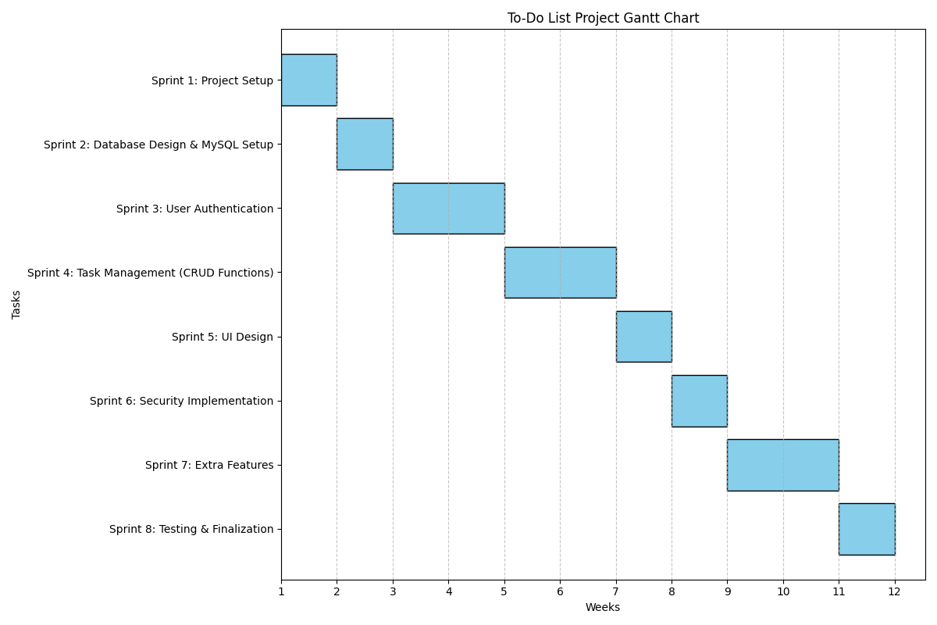

College equipment required:
Microsoft Azure Services/ Amazon Web Services license

(c) Ethical issues
Has the student consulted the guidelines on research with ethical implications? yes/no.
See “Key Information” tile on Moodle: https://moodle.bbk.ac.uk/course/view.php?id=44270

(d) Supervisor details
Name: | Date agreed:
- Proposal and Report Marking

Please note the following descriptions of projects of types 2, 3 and 4, as given in the Project Briefing document.

Type 2: Information Systems Research projects (BSc in ISM only)
An Information Systems Research project involves the investigation of information systems phenomena usually using interpretative research methods such as case studies or action research. Often the phenomena are newly emergent technologies and their social settings, development approaches or some aspect of the success or failure of an information system. Students who are considering a Type 2 project must take the module Research Methods in Management prior to enrolling for the project module. Supervision is carried out by the SCMS.

Type 3: Information Systems Development projects
An Information Systems Development project could involve the requirements capture and design of an information system or the evaluation of an existing system in order to identify problems and suggest improvements. Code may be written to check the feasibility of requirements or for comparison with existing code. Supervision is carried out by the SCMS. Any code implemented during the project must be demonstrated to the supervisor and supplied on a disk or USB memory.

Type 4: Computing projects
A Computing project involves the use of one or more programming languages for implementing a system or for investigating particular algorithms and data processing methods or for investigating computer based models of natural or artificial phenomena. Supervision is carried out by the SCMS. Any code implemented during the project must be demonstrated to the supervisor and supplied on a disk or USB memory.

BSc project submissions are evaluated against five criteria, as shown in the table below. Default weights per criterion are used, namely 15%, 15%, 50%, 20%.

Marks and feedback appear on Moodle. Please note that any marks shown on Moodle are the original marks, i.e. no capping due to late submission, penalty due to plagiarism allegation or other assessment offence is applied to marks shown on Moodle.

The marking scheme provided below is for information only. Project submissions are marked online, i.e. markers complete parts (a) and (b) of the table shown below online using marking forms provided on Moodle. Fixed weights for the marking criteria, as shown below, are used.

- Marker’s report

First/Second/Third Marker [Delete as appropriate]  Name: | Date received:
Criterion A: Proposal

Mark ............ out of ....15%....
Criterion B: Awareness and understanding of related work

Mark ............ out of ....15%....
Criterion C: Achievement, taking into account the difficulty of the project and also including but not limited to
Type 2: understanding and investigation of information systems phenomena
Type 3: requirements capture, design or evaluation of an information system
Type 4: design, layout and effectiveness of the code. If you are the supervisor, then indicate when you saw the code demonstrated.

Mark ............ out of ....50%...
Criterion D: Grammar, spelling, structure and coherence of the report, ability to present complex or technical material

Mark ............ out of ....20%...
Date returned: |  | Total ............ out of 100%

- Student feedback

Feedback is provided on Moodle. Markers fill in the corresponding fields in the Marking form on Moodle. When marks become available, students should check the "Grade column" on Moodle- mark will be shown out of 100. To read the feedback students should click on the Turnitin icon to access the Turnitin Feedback Studio- then click the "Rubric/Form" icon (right side panel on Turnitin) to access the feedback.

REFERENCES

  - Node.js Documentation (2024). Available at: https://nodejs.org/en/docs/ (Accessed: 14 November 2024).
  - Oracle. (n.d.). What is MySQL?. Available at: https://www.oracle.com/uk/mysql/what-is-mysql/ (Accessed: 14 November 2024).
  - Forest Admin (n.d.) 'All the basics (and more) you should know about CRUD operations'. Available at: https://www.forestadmin.com/blog/all-the-basics-and-more-you-should-know-about-crud-operations/ (Accessed: 15 November 2023).
  - React 2024, Tutorial: Intro to React, React Documentation. Available at: https://legacy.reactjs.org/tutorial/tutorial.html (Accessed: 15 November 2024).
  - Mozilla Developer Network (MDN) 2024, HTML basics - Learn web development, MDN Web Docs. Available at: https://developer.mozilla.org/en-US/docs/Learn/Getting_started_with_the_web/HTML_basics (Accessed: 15 November 2024).
  - GDPR Info. (n.d.). General Data Protection Regulation (GDPR). Available at: https://gdpr-info.eu/ (Accessed: 14 November 2024).

